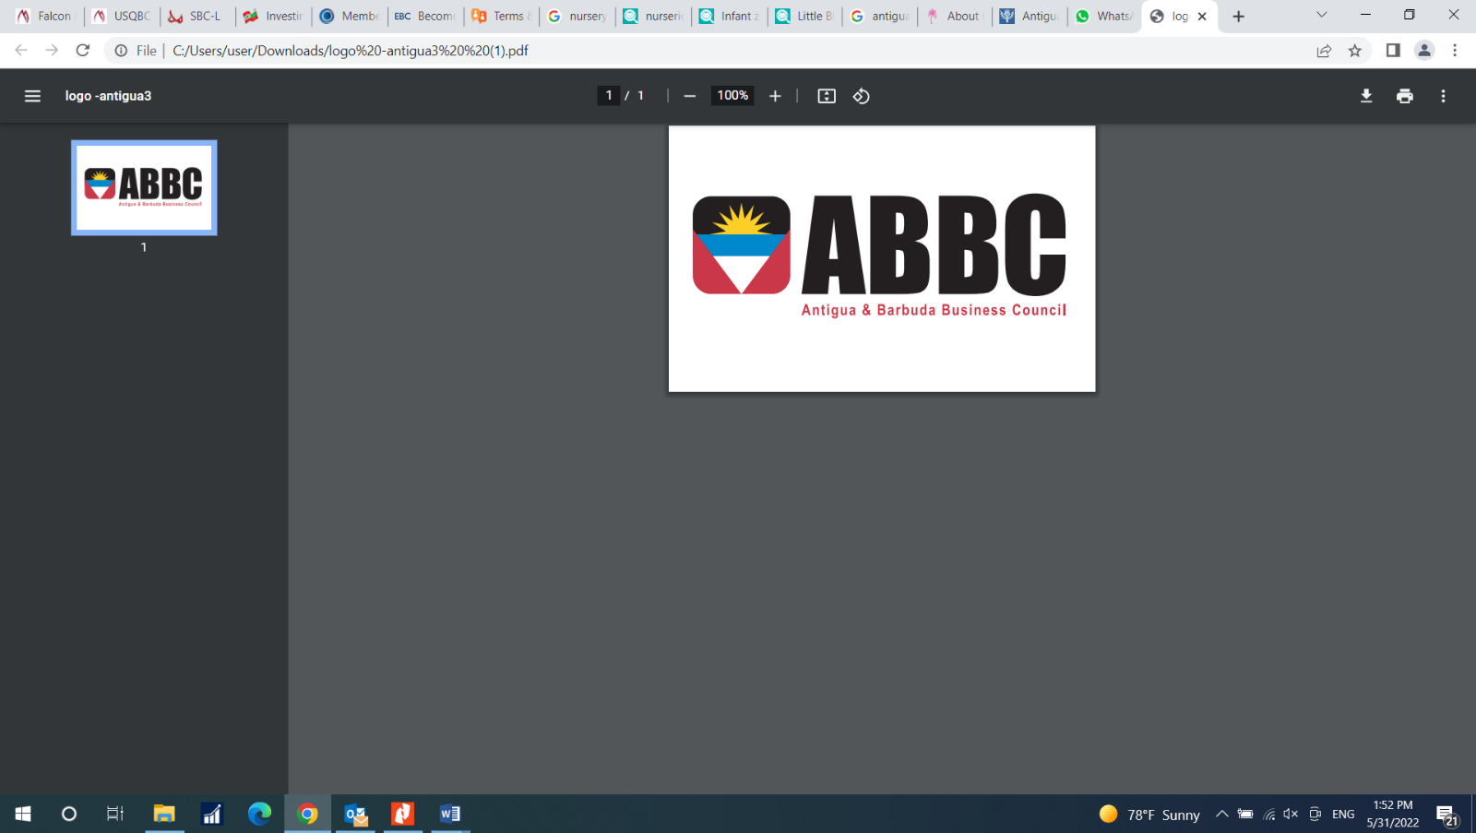

**Application Form**

**Personal Information**

|  |
| --- |
| Photo |

First Name: ___________________________________

Family Name: __________________________________

Company Name: ______________________________

Position: ______________________________________

Mobile Phone: __________________________________

Fax: _________________________________________

E-mail: _______________________________________

Website: ______________________________________

Address: ______________________________________

Postal Code: ____________________________________________________

P.O. Box: ______________________________________________________

City/Country: __________________________________________________________

**Please specify your membership category to ABCL**:

Antiguan Individual Membership

Membership in this category shall be open to Antiguan citizens and green card holders who are working in foreign countries, except individuals who would qualify as the representative of an Antiguan Business Member

Antiguan Business Membership

Membership in this category shall be open to Antiguan businesses present .

Ex-Officio Membership

Membership in this category shall be offered to Antigua and Barbuda and foreign government and chamber of Commerce officials occupying such positions as are designated by the Board of Directors

Specific nature of relationship (commercial rep. agent, etc.): ________________

____________________________________________________________

**Please describe your business activities**: (Goods, Services, Others)

_________________________________________________________________

_________________________________________________________________

_________________________________________________________________

**Please specify your areas of interest:**

|  |  |
| --- | --- |
|  Airlines |  Manufacturing |
|  Audit and Advisory Services |  Marketing, Sales & PR |
|  Agriculture |  Real Estate & Development |
|  Banking and Wealth Management |  Social & Business Events |
|  Construction |  Supply chain management |
|  Education |  Technology (biotech, IT, machines, medical) |
|  Food and Beverages |  Transportation, Freight, import/export |
|  Health Care |  Travel & Leisure |
|  Insurance |  Venture Capital |
|  Luxury & Retail Goods |  Other |
|  Law & Regulatory Issues |  |

 I would like to receive ABBC bulletins, industry reports, and offers.

I would like to become a member of The Antigua Business Council. I hereby consent that this application is subject to the approval of the Administrative Board Members. I declare all the information provided herein truthful.

Date: _______________ Signature of Applicant: ___________________